Station 1- Powers
Book Pages 12-13, & 45

Example:
- Evaluate the power 5³
5 x 5 x 5 =
5 x 5 = 25
25 x 5 = 125
Problems: Find the value of the Power
- 7³
- 2⁶
- 4⁴
- 5²
- 8³
Station 2 - Evaluating Expressions
Book Pages 16-21, 46

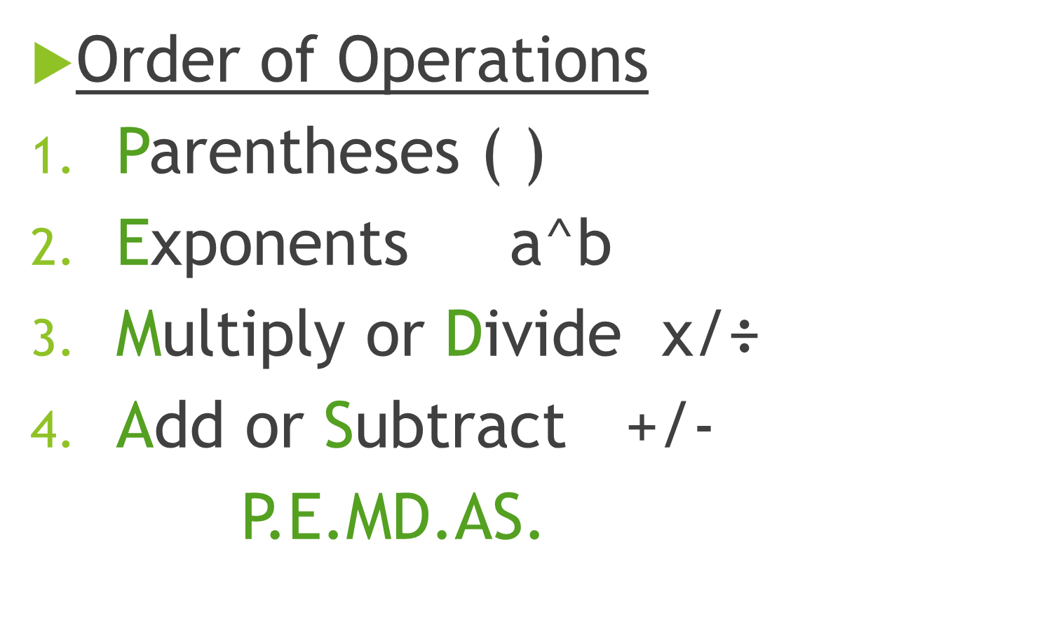
Example:
4³- 15 ÷ 5
64 – 15 ÷5 Solve 4³
64 – 3 Divide
= 61 Subtract
Problems: Evaluate the Expression
- 3 x 6 – 12 ÷ 6
- 20 x (3² – 4) ÷ 50
- 5 + ( 4² + 2) ÷ 6
- (6² -3) x (2 + 8)
- 4³÷2 – (7 -5)²

Station 3 – Prime Factorization
- Prime- only divisible by itself and 1.
- Composite- divisible by another number other than itself and 1.
- Factor Pair
- Example: 5 x 4 = 20 5 and 4 are a factor pair
- Prime Factorization – a number written as a product of its prime factors.
- Example: 20 Prime Factorization 2² • 5

Factor Trees can be used to find prime factorization. Example:
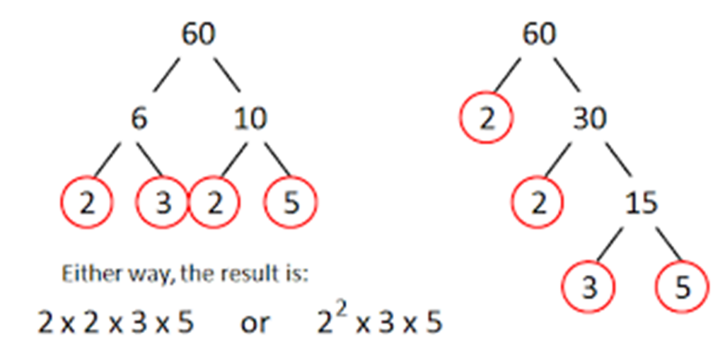
Problems: Find the prime factorization of the following;
- 42
- 50
- 66
- 28
- 63

Station 4 – Greatest Common Factor (GCF)
- Common Factors – factors that two or more numbers share.
- Greatest Common Factors (GCF)- the highest number among the common factors.
- Method 1 – Using lists of factors.
Step 1 – list the factors of each number
Step 2 – identify all common factors
Step 3 – Find the highest number out of the common factors

Example:
Factors of 24: 1, 2, 3, 4, 6, 8, 12, 24
Factors of 40: 1, 2, 4, 5, 8, 10, 20, 40
GCF = 8
Problems: Find the GCF for each set of numbers
- 27, 45
- 30, 48
- 28, 48, 64
- 24, 90
- 52, 68

Station 5 – Least Common Multiple
- Common Multiples- multiples shared by two or more numbers.
- Least Common Multiple (LCM)- the smallest common multiple.
1. List multiples of each number.
2. Circle common multiples
3. Identify the smallest common multiple

Example: Find the LCM of 4 and 6
4: 4, 8, 12, 16, 20, 24, 28, 32, 36
6: 6, 12, 18, 24, 30, 36
LCM = 12
Problems: Find the LCM of each set of numbers
- 4,14
- 6, 20
- 12, 28
- 10, 12
- 18, 27

Station 7- Adding and Subtracting Decimals

Step 1: Line decimals up
Step 2: Add or subtract like a regular addition or subtraction problem.

Examples:
19.2 45.6
+2.3 -12.8

Problems:
- 23.6 + 12
- 137.2 + 48. 4
- 34.65 + 12.16
- 123.65 – 14.6
- 52 – 14.2

Station 8 – Multiplying and Dividing Decimals
Multiplying Decimals
- Multiply just like whole numbers.
- Then count the number of digits to the right of the decimal point. In the product, move the decimal that many places to the left.
13.91 6.218
x 7 x 4
97.37 24.872

Dividing Decimals
- Place the decimal point in the quotient above the decimal point in the dividend. Then divide as you would with whole numbers. Continue until there is no remainder.
_1.83 _
$4$ 7.32

Problems:
- 6.1 x 7
- .27 x 4.42
- .051 x .244
- 6.8 ÷ 4
- 22.23 ÷ 3.9
Station 9 – Evaluating Expressions #2

Example: Evaluate the expression when x = 48 and y = 8; x ÷ y
48 ÷ 8 Substitute 48 in for x and 8 in for y.
= 6 Divide and solve.

*Substitute the numbers in for the variables.

Problems:
Evaluate the expression when x = 20 and y=4
- x ÷ 5
- y + x
- 8y – x
- In a video game, you score p points and b triple bonus points. An expression for your score is p + 3b. What is your score when you earn 245 game points and 20 triple bonus points?
- Evaluate the expression y²- 14 when y = 5.

Station 10 – Writing Expressions
Identify key words such as these:
Use them to write expressions.
Example: Write the phrase as an expression. 8 fewer than 21.
8 fewer than 21 fewer than usually means subtraction. 8 fewer in this case, or 8 less. That means I’m starting with something (21) and have to take away 8 from it.
21 – 8

Problems:
- 5 less than 8
- The product of 3 and 12
- A number b squared.
- Twice a number z
- 7 increased by a number w

Station 11- Simplifying and Identifying Properties
- Communitive Property- Switching the order of numbers does not matter. (+, x)
- Example:
15 +16 = 16 +15
a + b = b + a

- Associative Property – changing the group of numbers we solve first doesn’t matter. (+, x)
- Ex:
(3 + 4) + 5 = 3 + (4 +5)
(a + b) +c = a + (b + c)

- Distributive Property –
Examples
- 3(7 +2) = (3 x 7) + (3 x 2)
- a(b + c) = ab + ac

Property of 0’s and 1 – If there is a 0, specify whether it is the addition or multiplication property of 0. Property of 1 is only mentioned with multiplication.
Problems:
Tell which property the statement illustrates
- x + 7.5 = 7.5 + x
- 2 + (12 + r) = (2 + 12) + r
- ( c + 2 ) + 0 = c + 2
Simplify
- 8(3s)
- (2.4 + 4n) + 9
Station 12 – Areas of Parallelograms and rectangles (and perimeter)

Perimeter – Distance around the edge (all sides added up)
Area- measure of the inside of a shape.

Area of a parallelogram= Area = base x height
A = bh
*Same as a rectangle

Problems: Find the area of the parallelogram.

Station 13 – Area of triangles

Area of Triangle = ½ of base x height
A = ½ bh
*You can also think of taking ½ of something as cutting it in half or dividing by 2. You can divide the base or the height by 2 as the first step if you prefer, or you can wait until after you have multiplied base and height to divide by 2. It works either way!

Problems: Find the area of each triangle.

Station 14- Area of Trapezoids

Area = ½ height x (base 1 + base 2)
Examples:
Problems: Find the area of the trapezoids
3. h= 6 in , b₁= 9 in, b₂= 11 in
4. h= 22 cm , b₁= 10.5 cm, b₂= 12.5cm
5. h= 3 m , b₁= 6 m, b₂= 12 m

Station 15 – Areas of Figures
*Split figures into shapes with areas you already know (rectangles, parallelograms, triangles, trapezoids) and solve for each area individually. Add all areas at the end.
Example: Find the area of the composite figure.
Problems: Find the area of the composite figures.

- 5. .

Station 16 – Coordinate Plane Shapes

Problems: You might want to grab a piece of grid paper for these and attach to your packet.
Draw the polygon with the given vertices in a coordinate plane.
- A(3,2), B(4,7), C(6,0)
- K(3, 3 ½ ), L(5,7), M(8,7), N(6, 3 ½ )
Find the perimeter and area of the polygon with the given vertices.
- P(4,3), Q(4,7), R(9,7), S(9,3)
- T(2,7), U(2,9), V(5,9), W(5,7)
- W(11,2), X(11,8), Y(14,8), Z(14,2)
Station 17- Ratios
Problems: Write the ratios and explain what the ratio means.
- During a checkers game there are 16 pieces left. The ratio of black to red is 3:5. How many black pieces are on the board?
- There are 48 students in a school play. The ratio of boys to girls is 5:7. How many more girls than boys are in the play?

- Twelve of the 28 students in a class have a dog. What is the ratio of students who have a dog to students who do not?
Station 18- Ratio tables

Problems: Fill in the missing values in the ratio tables.
1. 2.
Boys | 1
Girls | 5 | 10
Taxis | 6 |  | 36
Buses | 5 | 15

Burgers | 3 |  | 9
Hot Dogs | 5 | 10
3.

Towels | 14 | 7
Blankets | 8 |  | 16
4.

Forks | 16 | 8
Spoons | 10 |  | 30
5.

Station 19 – Unit Rates

Unit Rate- a quantity compared to 1.

Finding a Unit Rate
* Divide ratio and replace b with 1
a:b a/b:1
Ex: Find a unit rate for $20:5 cans
20:5 20/5 : 1 $4:1can
Using a Unit Rate
How much money would you get for 7 cans?
Since the unit rate is $4 for 1 can, we know that we can take $4 x 7 to find the value of 7 cans. 4 x7 = 28 cans.
Problems:
- 12 stunts in 4 movies
- 3600 stitches in 3 minutes
- 342 tickets sold in 3 minutes.
- A horse can run 165 feet in 3 seconds. At this rate how far can the horse run in 5 seconds.
- A song has 28 beats in 4 seconds. At this rate, how many beats are there in 30 seconds?
Station 20- Comparing ratios
*You have to find a common multiple or factor! Treat like a fraction.
Steps to compare ratios using a ratio table...
- Set up a ratio table
- Choose the values you want to make equal
- Find a common multiple or factor of those values
- Form rates with common multiple or factor
- Compare
Ex.

Problems:
Station 21- Percents
- Writing Percents as Fractions – write percents as fractions with a denominator of 100
Example: Write 30% as a fraction

30% $\frac{30}{100} →$ simplify $→\frac{3}{10}$

- Writing Fractions as percents - Write equivalent fraction with a denominator of 100, then write numerator as %
Example: Write $\frac{3}{10}$ as percent.
$$\frac{3}{10}→\frac{30}{100}→30\%$$

OR Divide the numerator by the denominator and then move the decimal place over to the right twice (multiply by 100).
3 ÷10 = .3 30%

Problems: Write the percent as a fraction or the fraction as a percent.
- 12%
- 88%
- .8%
- $\frac{3}{5}$
- $\frac{43}{25}$
- $1\frac{21}{50}$

Station 22 – Find Percents and Wholes

Finding percent OF a number
Method 1- Mental Math Example:
Method 2 – Multiply by a decimal.
- Step1 – Write % as a decimal
- Step 2 – Multiply by the whole #
- Ex: 20% of 60 is what number?
20% .2
.2 x 60 = 12

Finding the whole
- Part ÷ % = whole
- Ex: 75% of what number is 48?
48 ÷ .75 $=$
$48÷ .75=64$
Station 22

Problems:
Find the percent of the number.
- 60% of 80
- 80% of 55
- 150% of 48
- 70% of what number is 35?
- 140% of what number is 56?

Station 23 – Converting

If the measures are metric, (meters, grams, liters) then use KHDBdcm (king henry died by drinking chocolate milk)

K (kilo)
H (hector)
D (deca)
B (base; meter, gram, liter)
d (deci)
c (centi)
m (mili)
Example: How many millimeters in 13 meters?
K H D B d c m
13
Meter is a base so we start at B. To get to millimeters we would have to move to the right 3 places. Add a decimal on to the end of the 13 and move over 3 times! Add 0’s into the empty spaces.
13 m = 13000 mm
Problems:
- How many meters are in 5 kilometers?
- 12 mL = ____ L
- 8 Dg = ____ cg
- 15 mm = _____dm
- 111.5 mg = _____ g
Station 24- Integers and Negative Numbers

*An integer is any whole number and its opposite (fractions are not included) *Think of negative numbers like a thermometer or sea level, anything below 0 is negative.

Problems:
Graph the integer and its opposite
- -7
Order the Integers from least to greatest.
- -5, 4, 2, -3, -1
- 5, -20, -10, 10, 15
Graph the number and its opposite.
- -$1\frac{3}{4}$
Copy and complete the statement using < or >
- -3.27 ____ -2.68

Station 25 – Absolute Value

*Absolute value is how far away from 0 a number is. For example if I have a point at -4, it is 4 values away from 0, so the absolute value of -4 is 4. Absolute value is always positive! Absolute value symbols = l l

Problems:
Find the absolute value.
- | -8 |
- |$3\frac{6}{7}$|
Copy and complete the statement using <, >, or =
- l -2 l ____ 2
- l 4.4 l ____ l -2.8 l
- |$\frac{1}{6}$| _____ |$-\frac{2 }{9}$ |

Station 26 – Coordinate Plane
No Notes for this one! You’re going to have to look up anything you don’t know on pg. 276 in the green math book.

Problems
- Please draw a coordinate plane labeling each quadrant, axis, and origin.
- Give an example of an ordered pair and tell me which number represents each axis.
Plot the ordered pair in a coordinate plane. Describe the location of the point. (All points may be plotted on one coordinate plane).
- A (-4, -2)
- B (0, -3)
- C( -1, 2)

Station 27 – Writing Equations
*When writing equations look for key words to tell you what numbers and operations to use. Ignore everything else.
Problems:
Write the word sentence as an equation
- 9 times a number b is 36.
- 5 is one-forth of a number c.
- 11 is the quotient of a number y and 6.
Which is different? Write “both” equations.

- 4 less than a number n is 8
- A number n is 4 less than 8.
- A number n minus 4 equals 8.
- 4 subtracted from a number n is 8.
Write an equation
- You sell instruments at a Caribbean music festival. You earn $326 by selling 12 sets of maracas, 6 sets of claves, and x djembe drums. Write an equation you can use to find the number of djembe drums you sold.
Station 28 – Solving Equations using + and –
*To solve equations, simplify and then always use inverses (the opposite operation from what is being shown in the equation)
Examples:
Problems:
Solve the equation
- f – 27 = 19
- a + 5.5 = 17.3
- 22 + 15 = d - 17
Tell whether the given value is a solution of the equation.
- w + 23 = 41; w = 28
- s – 68 = 11; s=79

Station 29 – Solving equations using multiplication and division

Problems: Solve the equation
- $\frac{s}{10}=7$
- $7x=105$
- 13 = d ÷6
- $\frac{2c}{15}=8.8$
- $7b ÷12=4.2$
Station 30- Two variable equations

Problems: Tell whether the ordered pair is a solution of the equation.
- y = 4x ; (0,4)
- y = 5x – 10 ; (3,5)
- y = x + 7 ; (1,6)
- y = 7x + 2 ; (2,0)
- y = 2x – 3 ; (4,5)

Station 31 - Writing Inequalities
*Write just like equations only with inequality symbols replacing the equals sign.
Graphing Inequalities
- Step 1 – draw a number line
- Step 2 – graph the number shown in the inequality by plotting an open or closed circle on the number line. O = < or >, ●= ≥ or ≤
- Step 3 – Shade in the side of the number line that holds the values included in the inequality and draw an arrow at the end. ( for example, if the inequality is x < 2, then that means x could be any number below two. Shade the line to the left of the two)
Problems
Write the word sentence as an inequality.
- A number z is fewer than ¾
- A number x divided by 3 is at most 5.
Graph the inequality
- X < $\frac{2}{9}$
- -3 ≥ x
- 1.5 > f
Station 32 – Solving Inequalities

*Solve just like equations. You don’t even have to worry about the symbol changing directions! Yet. At least not in 6th grade…

Problems: Solve the inequality and graph the solution
- x + 1 > 3
- s – 1.5 < 2.5
- b + 12 ≤26
- 9n ≥ 63
- $\frac{3}{11}k<15$

Station 33 – Solids

Number | Root
4 | Quad
5 | Pent
6 | Hex
7 | Hept
8 | Oct
9 | Non

Problems: Find the name, number of faces, number of edges, and number of vertices of the solid.
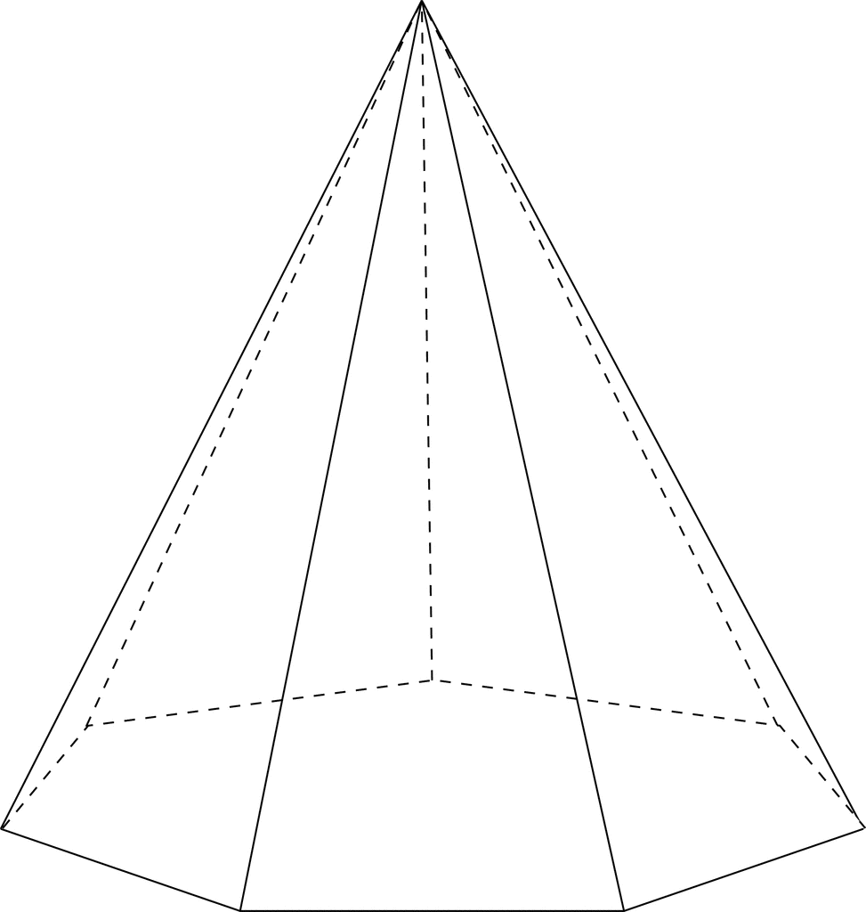
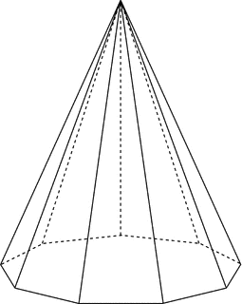
1.
4. 5.
3.
2.

Station 34 – Surface Area of Prisms
*Find the area of each shape that makes up the solid and then add the areas together to find the total surface area.

Problems: Find the surface area of the prism.

Station 35- Surface area of pyramids

*Find the area of each shape making up the pyramid and add them together to get the total surface area.

Problems: Find the surface area of each pyramid

Station 36- Volumes
*Always take the area of the base figure and multiply by the height. For the rectangular prism; Volume = length x width x height

Problems: Find the volume of each rectangular prism.

